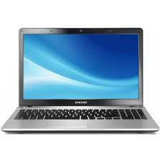

Samsung Laptop

* Intel Core I3-3110M
* 4GB 500GB
* 8GB Cache,To 2.4 GHz
* HD Graphics 4000 64Bits
* **Rs. 44,999**